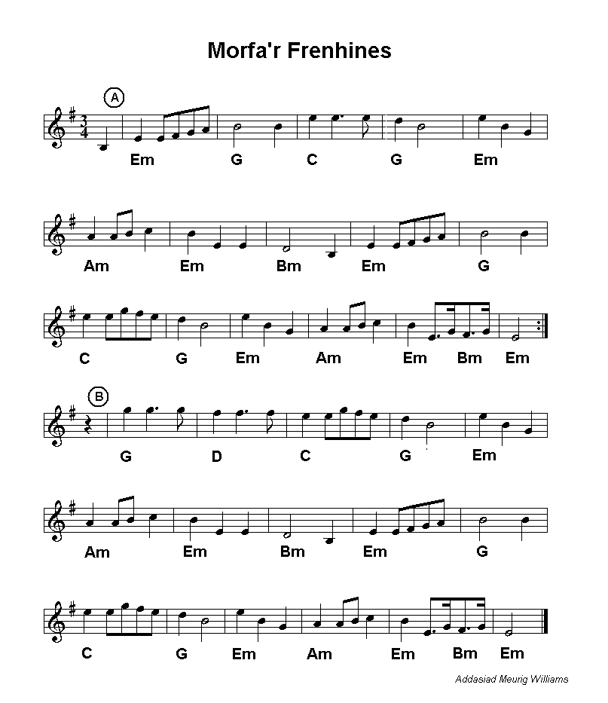
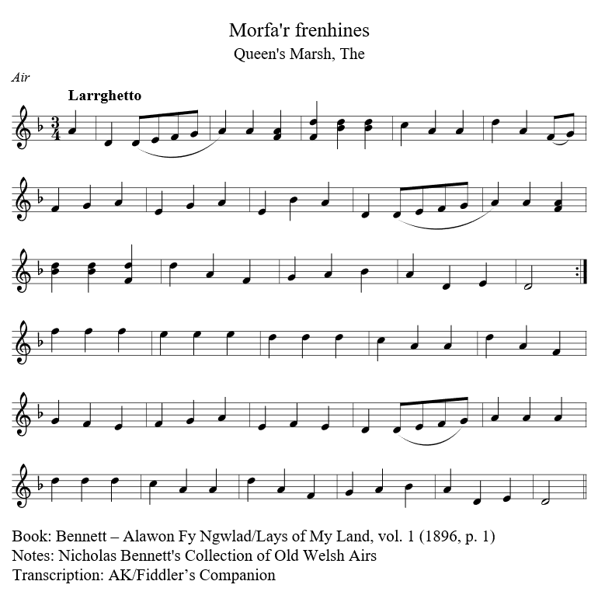
The Queen’s Marsh – Is Welsh and may be fond in Nicholas Bennett”s Collection of Old Welsh Airs – Alawon Fy Ngwlad/ Lays of My Land, vol.1 (1896).

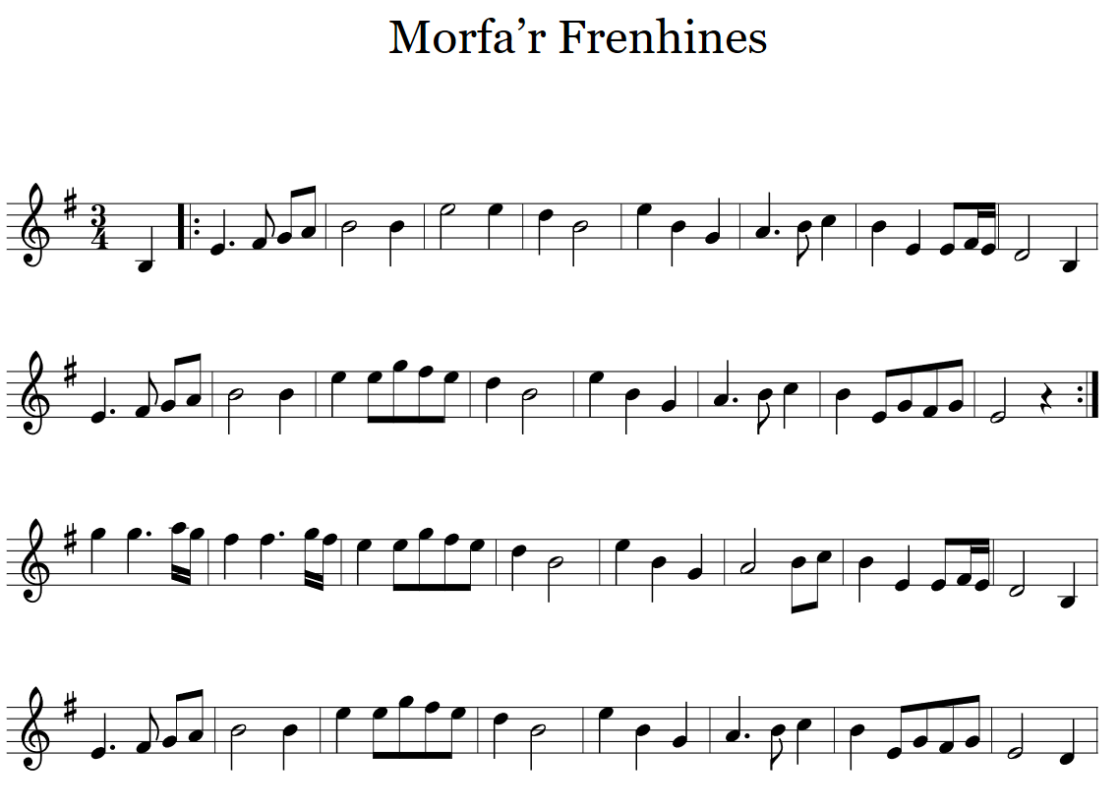

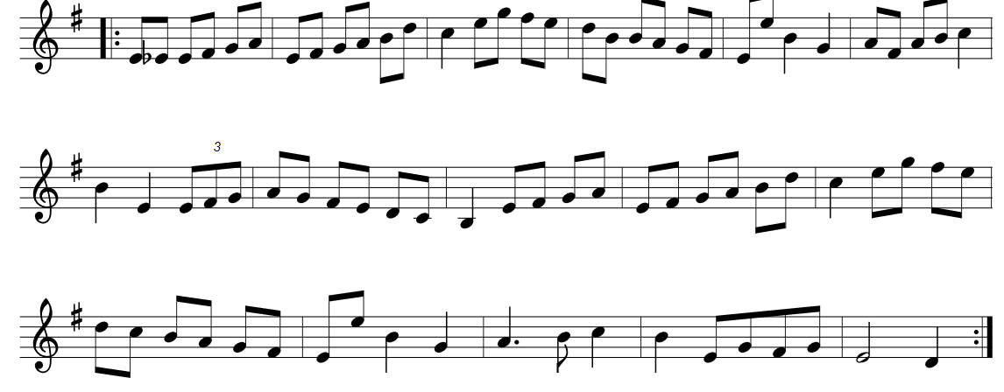
From: https://thesession.org/tunes/2910

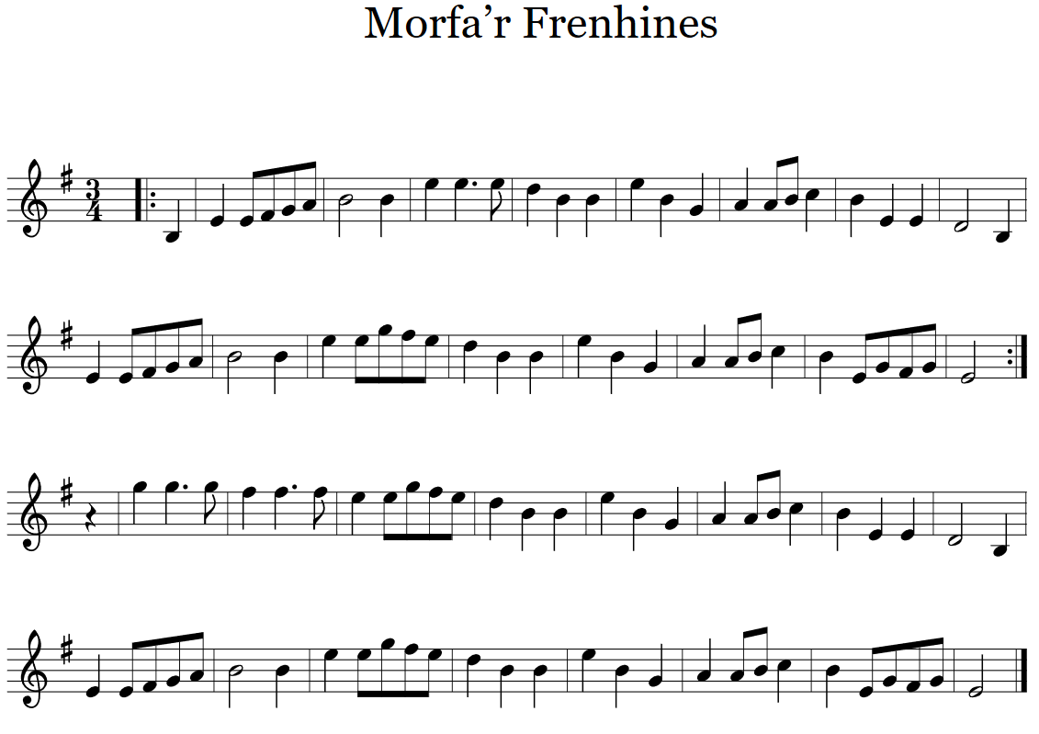
From: https://thesession.org/tunes/2910
