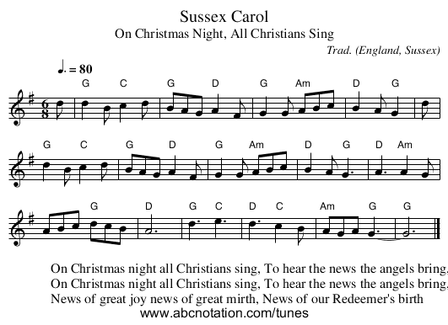

Sussex Carol
From Wikipedia, the free encyclopedia
Jump to: navigation, search
The "Sussex Carol" is a Christmas carol popular in Britain, sometimes referred to by its first line "On Christmas night all Christians sing". Its words were first published by Luke Wadding, a 17th-century Irish bishop, in a work called Small Garland of Pious and Godly Songs (1684). It is unclear whether Wadding wrote the song or was recording an earlier composition.^{[1][2]}
Both the text and the tune to which it is now sung were discovered and written down by Cecil Sharp in Buckland, Gloucestershire, and Ralph Vaughan Williams, who heard it being sung by a Harriet Verrall of Monk's Gate, near Horsham, Sussex (hence "Sussex Carol").^{[3]} The tune to which it is generally sung today is the one Vaughan Williams took down from Mrs. Verrall and published in 1919.^{[2]}
An earlier version using a different tune and a variation on the first line, "On Christmas night true Christians sing", was published as early as 1878 in Henry Ramsden Bramley and John Stainer's Christmas Carols New and Old.^{[4]} The carol has been arranged by a number of composers. Vaughan Williams' setting is found in his Eight Traditional English Carols.^{[5]}

