[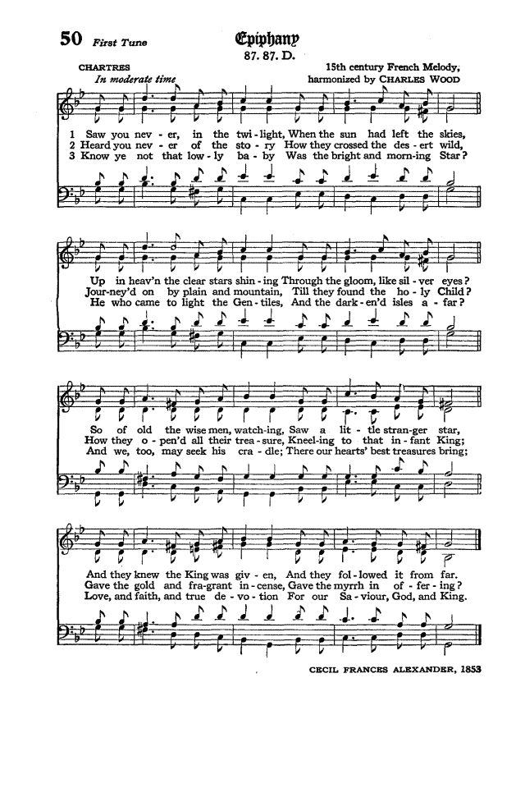](http://www.hymnary.org/hymn/HPEC1940/page/66)